**Project Plan**

***<<*** ***La Famiglia Pizzeria >>***

*<<John Doe>>*

|  |
| --- |
| **Date : 30/09/2023** |
| **Version : 2** |
| **State : Netherlands** |
| **Author : Renis Hila** |

Contents

1. Project assignment 3

1.1 Context 3

1.2 Goal of the project 3

1.3 Scope and preconditions 3

1.4 Strategy 3

1.5 Research questions and methodology 3

1.6 End products 4

2. Activities and time plan 5

2.1 Phases of the project 5

2.2 Time plan and milestones 5

3. Testing strategy and configuration management 6

3.1 Testing strategy 6

3.2 Test environment and required resources 6

3.3 Configuration management 6

4. Finances and risk 7

4.1 Risk and mitigation 7

# Project assignment

## Context

La Famiglia Pizzeria is a charming, family-owned restaurant dedicated to crafting and serving delicious pizzas.

## Goal of the project

Our primary goal is to create a website that enables customers to conveniently place online orders for pizza delivery to their doorstep. This initiative aims to eliminate any need for La Famiglia Pizzeria to turn away customers during peak times, ensuring they can serve everyone without any disruptions.

## Scope and preconditions

|  |  |
| --- | --- |
| **Inside scope:** | **Outside scope:** |
| 1. Development of a web application for online pizza ordering. | 1. Training manual for using the web application |
| 1. Regular weekly communication with the client to discuss project progress. | 1. Service and maintenance after delivering the application |
| 1. Documentation detailing the development process of the web application. | 1. Provision of hardware for the web application |
| 1. Integration of the web application with a database. |  |

**Preconditions:** The project will be developed using Java, JavaScript, and React for coding, and MySQL for the database. These technology choices have already been made by the restaurant.

## Strategy

The project will adopt the Scrum methodology as our chosen strategy. Scrum is selected for its ability to facilitate iterative development, enhance transparency, reduce risks, and provide flexibility and efficiency in executing the project.

## Research questions and methodology

**Methodology: We will employ a mixed-methods approach, blending qualitative interviews with clients and potential users to gauge their needs and expectations. Additionally, quantitative analysis of web application usage data will assess its effectiveness. Our development process will follow Scrum for iterative development and continuous feedback.**

**Research questions:**

1. How can a web application improve the ordering process for La Famiglia Pizzeria?
2. What are the key features needed in the web application to meet the needs of La Famiglia Pizzeria and its customers?
3. How can the Scrum methodology be effectively applied in the development of this web application?

## End products

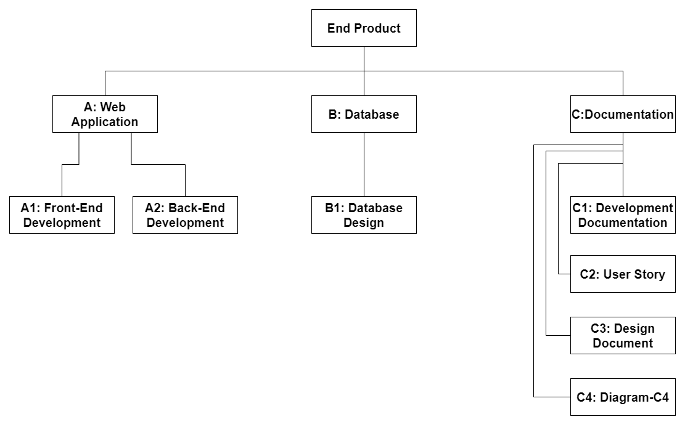

# Activities and time plan

## Phases of the project

**Sprint 1**: In this phase, will finish project plan, refine the product backlog, set up the initial backend with a RESTful API, create a GITLab repository for backend and initialize CI/CD environment.

**Sprint 2**: In this phase, will finish the design document, set up fronted GIT repository, create C4 Model diagrams and ensure fronted can consume at least one backend service.

**Sprint 3**: In this phase, will update the design document, set up backend to database, implement unit testing, install SonarQube and take screenshots of our project in SonarQube and new GIT pipeline.

**Sprint 4**: In this phase, will update the design document, implement authentication and authorization in our backend and fronted, ensure that all tests are passing in SonarQube, and take screenshot of our latest results.

**Sprint 5**: In this phase, will complete the final design document, prepare the security report, implement a Websockets feature, ensuring that all MVP features are implemented and ensure that all tests are passing in SonarQube.

**Sprint 6**: In this phase, will complete the final UX feedback report, ensure all MVP features are implemented, ensure all tests are passing in SonarQube and set up Continuous Delivery.

## Time plan and milestones

|  |  |  |  |
| --- | --- | --- | --- |
| **Phasing** | **Effort** | **Start date** | **Finish date** |
| 1. Sprint 1 |  | 04/09/2023 | 22/09/2023 |
| 1. Sprint 2 |  | 23/09/2023 | 13/10/2023 |
| 1. Sprint 3 |  | 14/10/2023 | 10/11/2023 |
| 1. Sprint 4 |  | 11/11/2023 | 01/12/2023 |
| 1. Sprint 5 |  | 02/12/2023 | 22/12/2023 |
| 1. Sprint 6 |  | 23/12/2023 | 19/01/2024 |

# Testing strategy and configuration management

## 

## Testing strategy

For our testing strategy, I'll use various methods:

1. Unit Tests: These are crucial for checking the core functionality of the business layer. We aim for at least 80% code coverage.
2. Component Tests: These assess individual classes independently, without integrating them with other components like modules, classes, objects, or programs.
3. Integration Tests: We'll test multiple components simultaneously, especially for complex processes. This includes testing a virtual database with various operations.
4. Controller Tests: These ensure that controller calls are stable, reliable, and return the expected results. We'll focus on selected classes, testing authentication and authorization features.
5. End-to-End Tests: Our frontend will handle these tests, evaluating the web application's speed, efficiency, and identifying potential issues. This is vital for ensuring our app can handle multiple requests and users simultaneously.

## Test environment and required resources

Tools like SonarQube, CI/CD pipeline, JUnit and automatic tests will be used to facilitate the testing process.

## Configuration management

I will be utilizing GITLab for version control in my project. Additionally, I plan to employ Trello both as a tool for managing my user stories and as a means for my professors to assess and monitor my project's progress.

# Finances and risk

## Risk and mitigation

|  |  |  |
| --- | --- | --- |
| **Risk** | **Prevention activities** | **Mitigation activities** |
| 1. Technology Risk | Ensure regular testing, cross-browser compatibility, cross-device checks, and code reviews for quality. | Prepare backup options, fix bugs promptly, and update as needed. |
| 1. Schedule Risk | Develop a realistic schedule, factor in buffer times for unexpected delays, and regularly monitor and update the schedule. | Prepare backup options, address delays promptly and adjust the schedule as necessary. |
| 1. Communication Risk | Establish clear communication channels, hold regular meetings and ensure all stakeholders are kept informed about project progress. | Address miscommunications promptly and maintain open lines of communication among stakeholders. |
| 1. Quality Risk | Set clear quality standards, conduct regular quality checks and use feedback to improve quality. | Address quality issues promptly, revise processes if necessary, and implement corrective actions to meet quality standards. |